SNC1P Mystery White Powder Activity Date:_________ Name:________

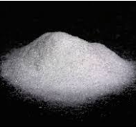**Goal:** to observe, describe and record how different powders interact with water and to predict how the powders are used.

**Materials:** Goggles

Beaker, graduated Cylinder, 1/8th teaspoon

Distilled water wash bottle

White powders (A and B)

Scoopula, Soap, Brush, paper towel for cleaning

**Instructions: Wear your Goggles during the activity and cleanup!**

1. Place 1/8th of a teaspoon of Powder A in a beaker.

Measure 10 mL of distilled water in the graduated cylinder.

Slowly pour the water onto Powder A.

Describe and record your observations in the chart.

1. Place 1/8th of a teaspoon of Powder B in a beaker.

Measure 10 mL of distilled water in the graduated cylinder.

Slowly pour the water into Powder B.

Describe and record your observations.

1. Keep adding water to powder B until no more can be absorbed. How much can you add?

Record your observations as you add more water to the powder.

1. To clean up, use the scoopula to scrape out the mixtures and put them in the garbage. Wash the beakers with soap and water using the brush. Leave them to dry on the rack.

**Observations:**

**Table 1: Reaction of Mystery Powders with Water**

|  |  |  |  |
| --- | --- | --- | --- |
| Mystery Powder | Powder before adding water  (colour, texture, size, etc) | Interaction of Powder  with 10 mL water | Observations when additional water is added |
| **A** |  |  |  |
| **B** |  |  |  |

**Discussion:**

1. How did powder A react when you added the water? Were you surprised by the behaviour of powder A? Please explain your answer.
2. How did powder B react when you added the water? Were you surprised by the behaviour of powder B? Please explain your answer.

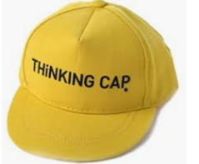**Application Question**: You are a scientist with Chemicals-R-Us Inc and you have just discovered powders A and B. In order to keep your job, you need to think of marketable applications for these two non-toxic chemicals and catchy names and marketing slogans. Get your thinking caps on!

**Powder A:**

**Powder B:**